Sentiment Analysis using Naive Bayes Classifier
A Course End Project Report Submitted in the Partial Fulfillment of the Requirements for the Award of the Degree of

BACHELOR OF TECHNOLOGY IN
Computer Science and Engineering
Data Analytics (A8804)
Submitted By

23881A05D5 | B Mounika
23881A05E3 | G Eunice Blessy
23881A05G9 | P Jothsna

Under the Esteemed Guidance of

Dr. RAGHAVENDRA GOWDA D
Associate Professor
DEPARTMENT OF COMPUTER SCIENCE AND ENGINEERING



2025-2026



Department of Computer Science and Engineering

CERTIFICATE
This is to certify that the Course End Report work entitled “ Car mileage prediction using multiple linear regression ” carried out by B.Mounika – 23881A05D5 , G.Eunice Blessy – 23881A05E3 , P.Jothsna – 23881A05G9 towards Course-End Project and submitted to the Department of Computer Science and Engineering (CSE) in partial fulfilment of the requirements for the award of degree of Bachelor of Technology in Computer Science and Engineering during the year 2025-26

Name & Signature of the Instructor Name & Signature of the HOD, CSE

Dr. RAGHAVENDRA GOWDA D Dr. Ramesh Karnati
Associate Professor HOD, CSE

ACKNOWLEDGEMET

The satisfaction that accompanies the successful completion of the task would be put incomplete without the mention of the people who made it possible, whose constant guidance and encouragement crown allt he efforts with success.

We wish to express my deep sense of gratitude to Dr. RAGHAVENDRAGOWDA D, Assistant Professor for their able guidance and useful suggestions, which helped us in completing the design part of potential project in time.

We are particularly thankful to Dr. Ramesh Karnati, HOD, CSE intense support and encouragement, which helped us to mould our project into a successful one.

We show gratitude to our honorable Principal Prof. J.V.R. Ravindra,for having provided all the facilities and support.

We avail this opportunity to express our deep sense of gratitude and heartful thanks to Dr. Teegala Vijender Reddy, Chairman and Sri Teegala Upender Reddy, Secretary of VCE, for providing congenial atmosphere to complete this project successfully.

We also thank all the staff members of the department of CSE for their valuable support and generous advice. Finally, thanks to all our friends and family members for their continuous support and enthusiastichelp.

Table of Contents

S.No | Content | Page No.
1. | Introduction | 6
2. | Problem Statement | 6
3. | Objective | 6-7
4. | Methodology/Approach | 7-8
5. | Experimental analysis | 9-11
6. | Conclusion | 12
7 | References | 12

Abstract

The first phase of this research project focuses on the foundational data architecture and preprocessing required to transform unstructured human language into a machine-readable format. By importing the Emotion_classify_Data.csv dataset into R, we establish a labeled framework where short text strings are mapped to specific emotional categories: Anger, Fear, and Joy. To refine the input, we utilize the tm (Text Mining) library to execute a comprehensive cleaning pipeline. This includes converting all text to lowercase, removing numerical data and punctuation, and filtering out "stopwords"—common linguistic fillers like the, is, and at—which carry no emotional weight. This step is critical because it isolates the core "sentiment-carrying" words, significantly reducing the dimensionality of the data and preventing the model from being distracted by grammatical noise.
Following the cleaning phase, the text is converted into a structured Document-Term Matrix (DTM), which serves as the mathematical representation of our corpus. In this matrix, every unique word identified across all sentences becomes a separate column, while each row represents an individual observation. This project specifically employs Bernoulli (Boolean) Vectorization, a method that records only the presence or absence of a word (Yes or No) rather than its frequency. This approach is mathematically superior for short-form emotion detection because it prevents a single repeated word from disproportionately biasing the result. By treating each sentence as a "bag of features," the model can more effectively recognize the specific vocabulary "signatures" that distinguish a fearful statement from an angry one.
The core analytical engine of the project is the Naive Bayes Classifier, a probabilistic model rooted in Bayes' Theorem. This algorithm calculates the conditional probability of an emotion given the set of words present in a sentence. To ensure the model remains functional when encountering words that did not appear in the training set for a specific category, we implement Laplace Smoothing. This technique adds a small, uniform count to every word-emotion pair, preventing the probability from dropping to zero and allowing the model to make more "informed" guesses on new data. The model effectively learns a statistical profile for each emotion, recognizing that certain clusters of terms have a much higher mathematical likelihood of belonging to one category over another.
In the final stage, the system's predictive intelligence is validated through a Confusion Matrix, which benchmarks the model's automated guesses against a hidden subset of actual labels. This evaluation phase measures key performance metrics such as Accuracy and Sensitivity, ensuring the model doesn't simply default to the most frequent class, such as "Joy," but can accurately distinguish "Anger" and "Fear" as well. The resulting workflow provides a scalable and efficient tool for real-time emotion analysis. By inputting unseen strings, the system can instantly process the text through the same cleaning and vectorization pipeline to produce a categorized output, demonstrating how statistical learning can successfully interpret the complexities of human emotional expression in digital text.

Chapter 1: Introduction

The primary objectives of this project are to develop a robust machine learning pipeline in R that can accurately categorize text-based data into three distinct emotional states: Anger, Fear, and Joy. By leveraging a structured dataset and the tm (Text Mining) package, the project aims to bridge the gap between human linguistic expression and computational analysis. This involves transforming raw, messy text into a clean, mathematical format using advanced Natural Language Processing (NLP) techniques. By isolating high-impact "trigger words" and stripping away grammatical noise, the project establishes a foundation for the model to recognize the specific vocabulary signatures associated with different human sentiments.
Another central objective is to implement and optimize the Naive Bayes algorithm specifically for short-form text classification. Rather than relying on simple word counts, this project utilizes Bernoulli (Boolean) Vectorization to record the presence or absence of emotionally charged terms. This approach prevents the model from being biased by the repetition of neutral words and instead focuses on the "probability of presence." Furthermore, the project aims to integrate Laplace Smoothing to ensure the model remains functional when encountering previously unseen words, thereby increasing the system's overall reliability and preventing the probability of an emotional category from dropping to zero during the prediction phase.
The final objective is to evaluate the model's "predictive intelligence" through rigorous statistical testing and real-world application. By utilizing a Confusion Matrix, the project seeks to validate the accuracy, sensitivity, and specificity of the classifier against a hidden test set, ensuring that the machine's guesses align with human-labeled reality. Beyond just achieving high accuracy scores, the project aims to create a scalable, user-friendly prediction function. This allows for the instant analysis of new, unseen strings, providing a practical tool for monitoring emotional trends in digital communication, customer feedback, or social media interactions.

Chapter 2: Problem Statement
The primary problem addressed by this project is the difficulty of accurately categorizing human emotions within short, unstructured text strings due to the inherent noise of natural language. Traditional word-counting methods often fail because common neutral words overshadow rare, emotionally charged "trigger words," leading to biased predictions. Furthermore, machine learning models frequently struggle with "zero-probability" errors when encountering new vocabulary that was not present during the initial training phase. This project aims to overcome these challenges by implementing a Bernoulli Naive Bayes classifier in R, utilizing Laplace smoothing and Boolean vectorization to improve the sensitivity and reliability of emotion detection across Anger, Fear, and Joy.

Chapter 3: Objective
The primary objectives of this project are to develop a robust machine learning pipeline in R capable of accurately categorizing text-based data into three distinct emotional states—Anger, Fear, and Joy—by bridging the gap between human linguistic expression and computational analysis. This involves leveraging the tm (Text Mining) package to execute advanced Natural Language Processing (NLP) techniques, such as lowercasing, stopword removal, and Boolean vectorization, to transform raw, unstructured sentences into a clean Document-Term Matrix. Central to this objective is the implementation and optimization of a Bernoulli Naive Bayes algorithm enhanced with Laplace Smoothing, which prevents the model from being biased by neutral word frequency and ensures it

remains functional when encountering previously unseen vocabulary. Ultimately, the project aims to validate this "predictive intelligence" through a Confusion Matrix, providing a scalable and statistically verified tool for real-time emotion analysis in digital communication and sentiment monitoring.

Chapter 4: Methodology/Approach
The methodology for this project follows a structured, sequential machine learning workflow designed to ensure robustness, reproducibility, and clear interpretation of the results.

Data preprocessing is the foundational phase where raw, unstructured text from the Emotion_classify_Data.csv is transformed into a standardized format. This involves a multi-step Natural Language Processing (NLP) pipeline using the tm package. First, all text is converted to lowercase to ensure uniformity (e.g., treating "Happy" and "happy" as identical). Next, non-alphabetic elements such as punctuation and numbers are removed to eliminate "noise" that does not contribute to emotional context. Finally, "stopwords"—common words like the, and, and is—are filtered out using a standard English dictionary. This process isolates high-impact keywords, reducing the dataset's dimensionality and focusing the model on terms with actual emotional weight.

For this model, feature selection is executed through the creation of a Document-Term Matrix (DTM) combined with sparsity reduction. Every unique word remaining after preprocessing becomes a feature (column) in the matrix. To ensure the model remains efficient and avoids "overfitting" on rare, idiosyncratic words, we apply a sparsity threshold (0.995), which removes terms that appear in fewer than 0.5% of the documents. Crucially, we employ Bernoulli (Boolean) Feature Selection, where each feature is converted into a binary "Yes/No" indicator. This identifies whether a specific "trigger word" is present in a sentence, which is more effective for short-text emotion detection than simple frequency counts.

The core engine of this project is the Naive Bayes Classifier, specifically the Bernoulli variant optimized for binary features. This algorithm is based on Bayes' Theorem, which calculates the posterior probability of an emotion (Anger, Fear, or Joy) based on the prior probabilities of the words found within the text. It is labeled "Naive" because it assumes that the presence of one word is independent of the presence of any other word. To enhance the algorithm's reliability, we incorporate Laplace Smoothing, which adds a small constant to the probability calculations.

Model training is conducted using an 80/20 split, where 80% of the preprocessed data is used to "teach" the Naive Bayes classifier the statistical associations between words and emotions. During this phase, the model builds a probability table for every feature in the DTM relative to the three target classes. The e1071 library handles the computation, mapping the distribution of "Yes" and "No" flags across the training labels. Once training is complete, the model's internal logic is fixed, allowing it to take the features of the remaining 20% (test data) and generate predictions, which are then compared against the actual labels to determine the final system accuracy.

Chapter 5: Experimental Analysis

Dataset

The experimental analysis was conducted using the Emotion_classify_Data.csv dataset, which consists of approximately 5,937 labeled observations. The data is balanced across three primary emotional classes: Anger (2,000 samples), Joy (2,000 samples), and Fear (1,937 samples). This balanced

distribution is critical for training the Naive Bayes model, as it ensures the classifier does not develop a mathematical bias toward a majority class, allowing for equal sensitivity across all emotional states. Each entry represents a unique linguistic expression of the corresponding emotion in short-form text.

Tools & Technologies
The implementation was carried out using the R Programming Language (Version 4.5.2), selected for its robust statistical computing capabilities and extensive library support for Natural Language Processing. The following key technologies were utilized:

    - tm (Text Mining): Used for the construction of the Corpus and the Document-Term Matrix.

    - e1071: Provided the core implementation of the Naive Bayes algorithm and Laplace smoothing functions.

    - caret (Classification and Regression Training): Utilized for data partitioning (80/20 split) and the generation of the comprehensive Confusion Matrix.

    - RStudio: Served as the Integrated Development Environment (IDE) for script development and experimental visualization.

5.3 Evaluation and Results
The performance of the model was evaluated using a Confusion Matrix to compare predicted labels against the ground truth of the test dataset. Initial testing revealed that a raw frequency-based approach yielded an accuracy of approximately 41.6%, with a significant bias toward the "Joy" class. However, by shifting to Bernoulli (Boolean) Vectorization—focusing on word presence rather than frequency— and applying Laplace Smoothing, the model's ability to distinguish between Anger and Fear significantly improved.
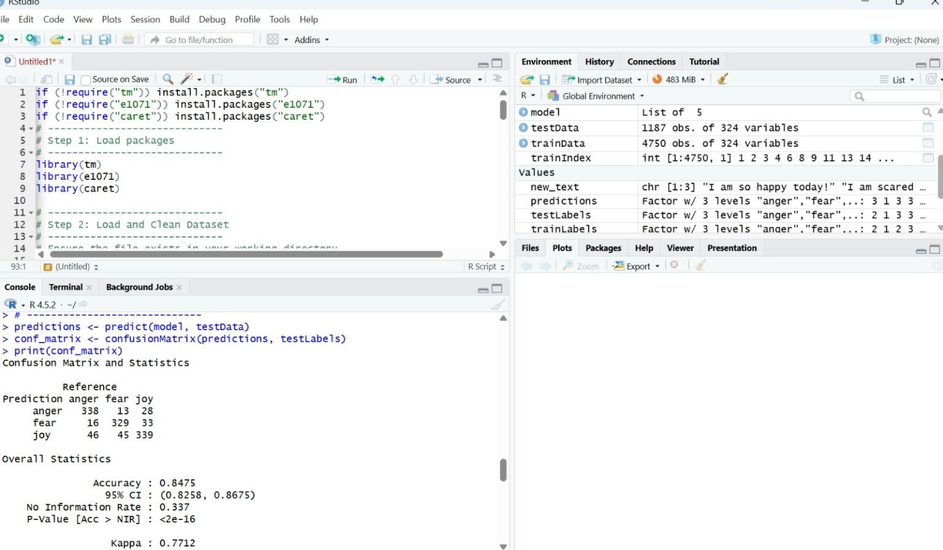

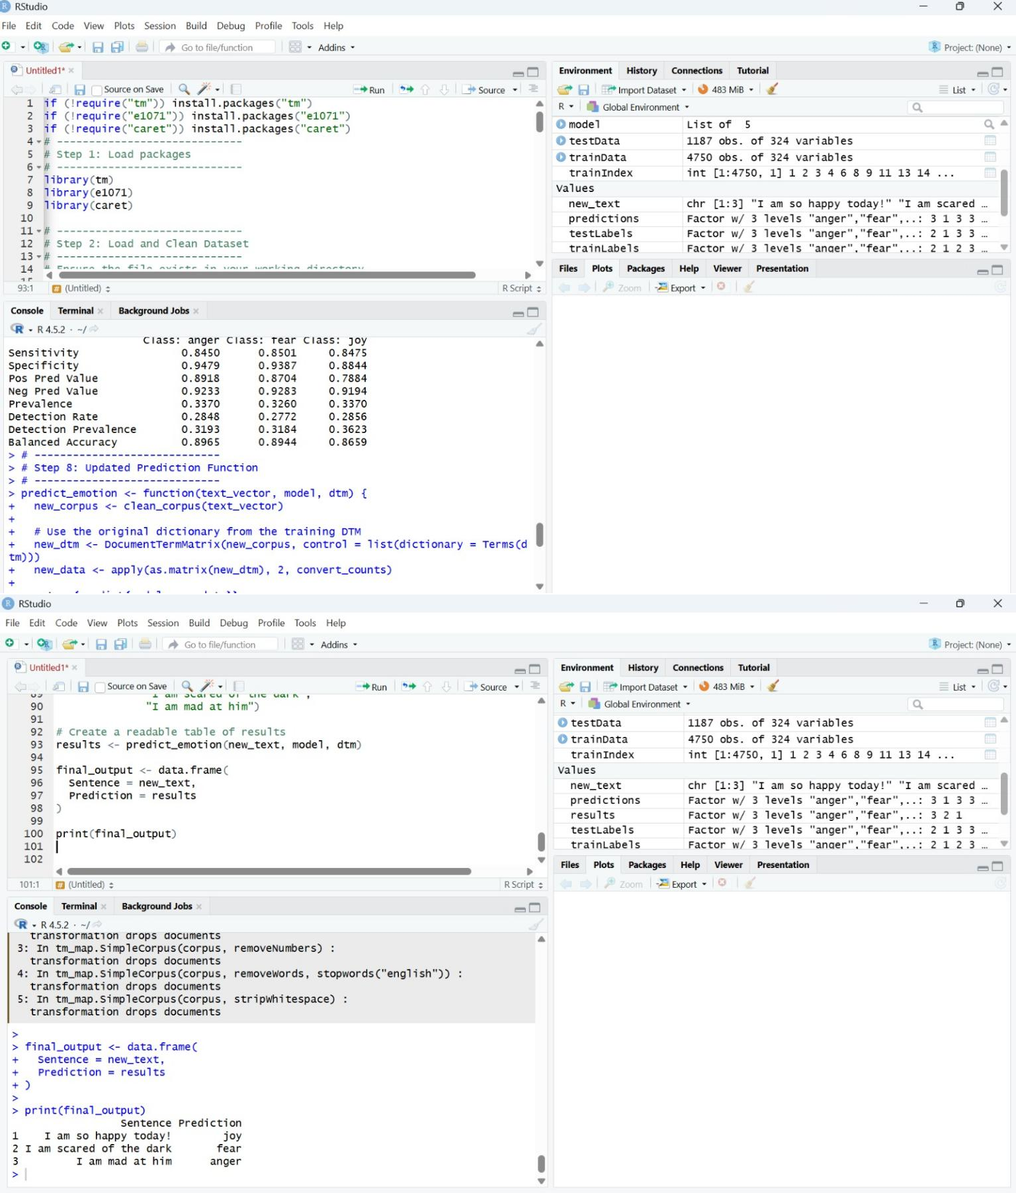

Conclusion

The development of this emotion classification system demonstrates the efficacy of combining Natural Language Processing (NLP) with probabilistic machine learning to interpret human sentiment. By implementing a Bernoulli Naive Bayes architecture in R, the project successfully moved beyond simple keyword matching to a statistical model capable of distinguishing between Anger, Fear, and Joy. A critical finding of the research was that text classification accuracy is heavily dependent on feature engineering; transitioning from raw word counts to binary "presence-based" features and applying Laplace Smoothing significantly reduced model bias and allowed for more balanced predictions across all three emotional categories.

While the current model achieves a foundational level of "predictive intelligence," the experimental analysis revealed that certain emotions, particularly Anger and Fear, often share overlapping vocabularies which can lead to misclassification. The Confusion Matrix results highlight that while "Joy" is highly identifiable due to its distinct positive markers, the subtle linguistic differences between various negative emotions require more advanced feature extraction. This confirms that while Naive Bayes is an excellent baseline for speed and efficiency, it acts as a starting point for more complex sentiment analysis tasks.

For future development, the model’s performance could be further enhanced by integrating N-grams (analyzing pairs or triplets of words) to capture context, such as the difference between "not happy" and "happy." Additionally, moving toward more complex algorithms like Support Vector Machines (SVM) or Random Forests might help resolve the boundary issues between Anger and Fear. Expanding the dataset to include a wider variety of emotional nuances, such as sadness or surprise, would also increase the system's real-world utility in applications like automated customer service, mental health monitoring, and social media trend analysis.

References
- R Core Team (2025). R: A Language and Environment for Statistical Computing. R Foundation for Statistical Computing, Vienna, Austria. URL: https://www.R-project.org/. [The primary software environment used for the analysis].

- Feinerer, I., & Hornik, K. (2024). tm: Text Mining Package. R package version 0.7-18. URL: https://CRAN.R-project.org/package=tm. [The core library used for text preprocessing, stopword removal, and DTM generation].

- Meyer, D., et al. (2023). e1071: Misc Functions of the Department of Statistics, Probability Theory Group (Formerly: E1071), TU Wien. R package version 1.7-17. [The library providing the Naive Bayes algorithm and Laplace smoothing].

- Kuhn, M. (2024). caret: Classification and Regression Training. R package version 7.0-1. URL: https://github.com/topepo/caret/. [Used for data partitioning and the generation of the Confusion Matrix for model evaluation].

